School Year 114, 2nd semester
“Everybody Up 1” Homework for Week 13(5/4-5/8)
Class: 202
英讀  星期一 | To Market, To Market ( Day 5/6 )

英語 | Listen, Read & Write 聽, 唸讀 & 寫 | Write 寫 | Others 其他
Day1 | U7 L2 p.74-75 | 練習簿 p.74  單字x3；句子x1 | 5/5(二)小考  範圍：U7 L1 p.72-73
Day2 | U7 L2 p.74-75 | 習作U7 L2 p.66-67 | 熟背單字句子：  U7 L2 p.74-75
Day3 | U7 L2 p.74-75 |  | 1. 5/12(二)小考  範圍：U7 L2 p.74-75  2. 訂簽：  習作、練習簿、小考卷

*考試通知

114學年度下學期「英語單字A冠王」檢測
教材Everybody Up Book 1
週次 | 日期 | 範圍 | 題型
第15週 | 5/21(四) | 第七單元 Unit 7 | 中翻英

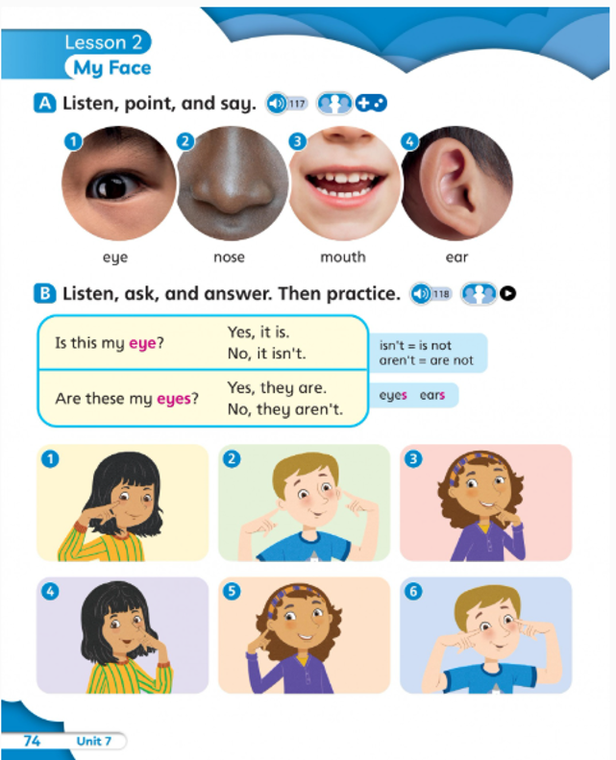

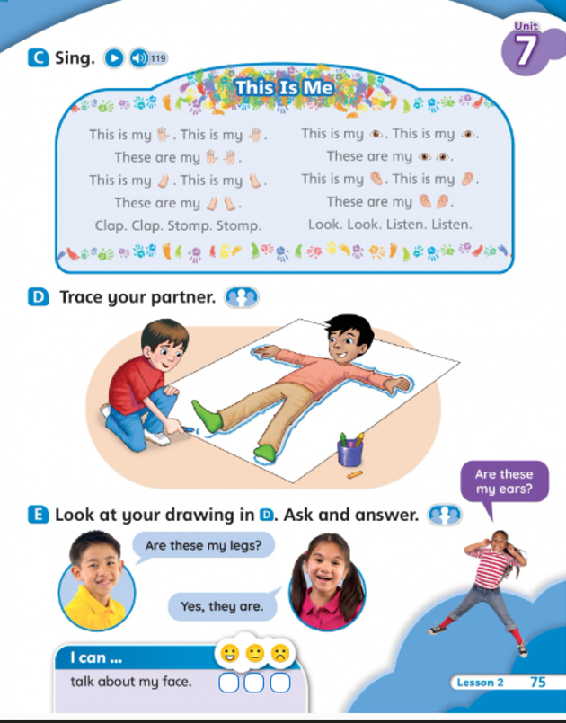

School Year 114, 2nd semester Class: 202
English Conversation weekly Class Schedule
English Textbook – Inside Out-1
Week 13 (5/3-5/9)
二年級 第13周 英會課聯絡單
英會 | Learn and Read | Classroom Learning Activities  課堂英語活動
Week 13  Date: 5/3-5/9/2026 | U7: A Birthday Party & Mother’s Day | Sentences practice & oral speaking  - Mother’s Day Song: Skidamarik -Storybook: My Mom is Fantastic  -Vocabulary:  carnations, flowers, gifts, cards, housework, baby, grow up  -When is the Mother’s Day? (the 2nd Sunday of May)  ~Mother’s Day Activity母親節活動
Oral Practice  口語練習/作業 | *What do you want/like for your birthday? I want/ like _______________________.  *Review Unit 7(複習第七單元)

