Class: 102
School Year 115, 1st semester "Everybody Up Starter" Homework for Week 2 (9/7-9/11)
英讀讀本 | Zac the Rat ( Day 2/3 )
項目/進度 | Listen, Speak & Read  📖 聽說讀  【課堂&回家作業】 | Write  ✍️ 寫  【課堂完成】 | Review  🔄 複習  【回家作業】
英語Day 1 | 課本  U1 L2 p.8-9 &  U2 L4 p.20-21  (Day 1~3共同進度) | ABC練習簿 | 熟練發音: 課本p.20-21  Ee, Ff, Gg
英語Day 2 | 課本  U1 L2 p.8-9 &  U2 L4 p.20-21  (Day 1~3共同進度) | WB 習作  U1 L2 p.6-7 | 熟背單字:  課本U1 L2 p.8
英語Day 3 | 課本  U1 L2 p.8-9 &  U2 L4 p.20-21  (Day 1~3共同進度) | ABC練習簿 | 熟背句子:  課本U1 L2 p.8

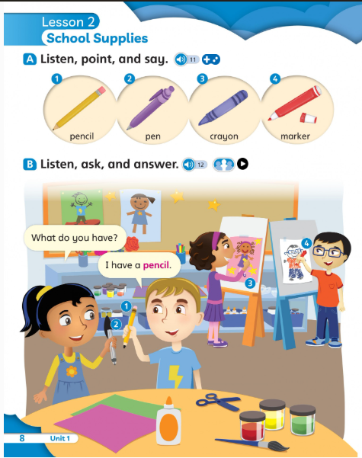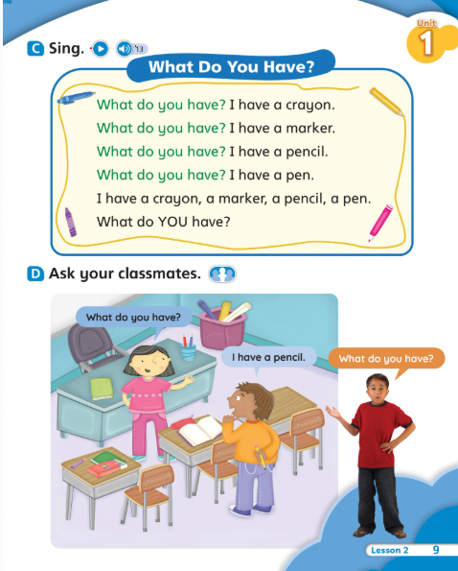
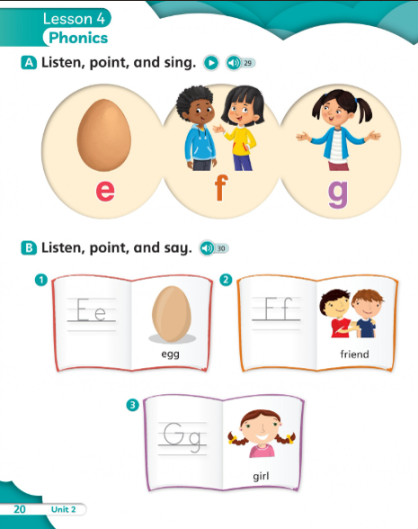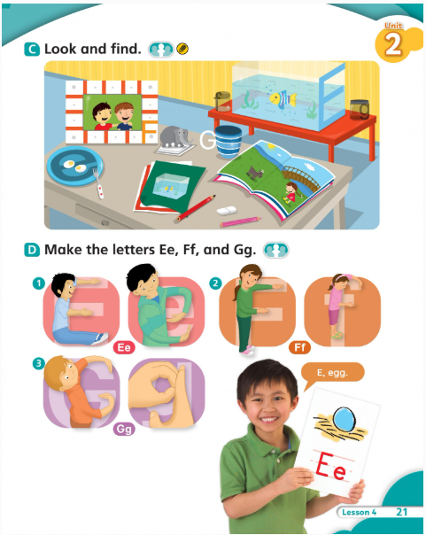

School Year 115, 1st semester Class: 102
English Conversation weekly Class Schedule
English Textbook – Inside Out-Starter
Week 2 (9/6-9/12)
一年級 第2周 英會課聯絡單
英會 | Learn and Read | Classroom Learning Activities  課堂英語活動
Week 2  Date: 9/6-9/12/2026 | Unit 1: New Class | Sentences practice & oral speaking  *Hello. I’m _____________. Hi. I’m ________________.  Nice to meet you.  *What is this? It is a desk. (__________________)
Oral Practice  口語練習/作業 | *Greetings/ Question-What is this?這是什麼?  *Review Unit 1(複習第一單元)

